- Clinical Coding Structure

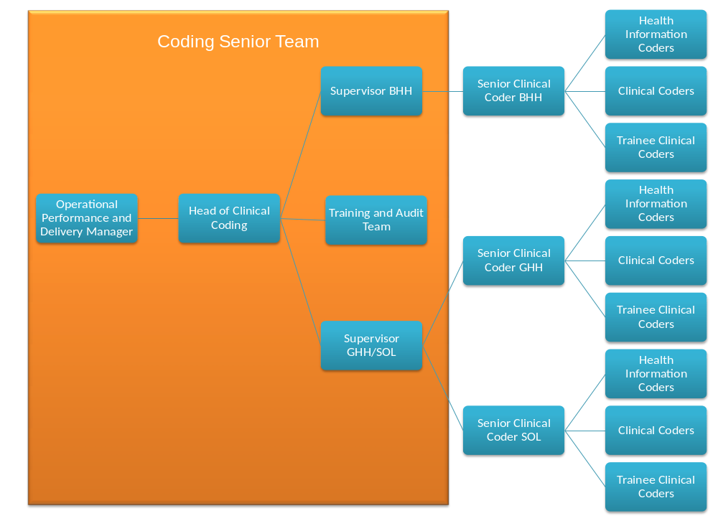
N.B. Senior clinical coders do not have line management responsibilities but may lead a cluster of staff.

