

Learning & Development Policy

Key Points:
- This policy explains how Heart of England NHS Foundation Trust will manage learning and development opportunities in a consistent and fair manner.
- The policy supports the delivery of strategic learning and development objectives to ensure: the right people, in the right place at the right time with the right skills to deliver safe, caring, innovative, locally engaged and efficient care.
- Provides tools to support the achievement of the strategic learning and development objectives

This policy is a re-write of the Training and Development policy following the launch of the Faculty of Education’s Learn Lead Strategy 2009 - 2014

Paper Copies of this Document
If you are reading a printed copy of this document please check the Trust’s Policy website (http://sharepoint/policies) to ensure that you are using the most current version.

Ratified Date: September 2014
Ratified By: JNCC
Review Date: Annual Review
Accountable Directorate: Human Resources
Corresponding Author: Faculty Divisional Managercarol.willis@heartofengland.nhs.uk
Table of Contents

1 Introduction 5
2 Circulation 6
3 Scope 6
4 Definitions 7
5 Reason for development 7
6 Aims and Objectives 7
7 Learning and Development Needs 8
7.1 Identification of Learning Needs 8
7.2 Meeting Learning and Development Needs 9
7.3 Prioritisation of Learning and Development Needs 10
8 Learning and Development Leave 10
8.1 Authorisation and allocation of learning and development leave 10
8.2 Management of Non-Attendance 10
9 Funding and Time Release for Learning and Development 10
9.1 Reimbursement of Expenses 12
9.2 Withdrawal or Repayment of Funding Support 13
9.3 Funding Streams 14
10 Appeals Mechanism 15
11 Recording, Monitoring and Evaluating Learning and Development 15
12 Responsibilities 15
12.1 Individual Responsibilities 15
12.1.1 Chief Executive 15
12.1.2 Executive Directors 15
12.1.3 Line Manager, Supervisor and Team Leader 16
12.1.4 Individual Employees 16
12.1.5 Training Providers 17
12.2 Board and Committee Responsibilities 17
12.2.1 Site Teams – Executive Team (Head of Operations, Associate Medical Director and Head Nurse) 17
12.2.2 Faculty of Education Board 17
12.2.3 Faculty of Education Management Committee 18
12.2.4 Curriculum Development Board 19
13 Training Requirements 19
15 Monitoring and Compliance 19
Attachment 1: Ratification Checklist 20
Attachment 2: Equality and Diversity - Policy Screening Checklist 23
Attachment 3: Launch and Implementation Plan 26
Attachment 4: Definitions 27
Attachment 5: Study Leave Process for Training and Non-training Doctors 28
Attachment 6: Example of a Qualifications, Skills and Knowledge Map and Training Needs Analysis 30
Attachment 7: Training Needs Analysis Template 31
Attachment 8: Example of a Training Plan 32
Attachment 9: Quick Reference Guide 33
Attachment 10: Learning & Development Financial Support Agreement 34
Attachment 11: Faculty Evaluation Form 36

Meta Data

Document Title: | Learning & Development Policy
Status | Final draft for comments before approval
Document Author: | Carol Willis, Faculty Principal Educator  Carol.willis@heartofengland.nhs.uk
Source Directorate: | Learning & Development:  Faculty of Education
Date Of Release:
Ratification Date
Ratified by:
Review Date:
Related documents | Learn Lead Workforce Development Strategy 2009-2014 (Faculty of Education, Heart of England NHS Foundation Trust 2009)  A High Quality Workforce: NHS Next Stage Review (DoH 2008)  West Midlands Deanery Study Leave Guidelines  Equal Opportunities policy  Strategic Training Needs Analysis and Education Plan 2010/11 (Clinical)  Secondment policy  Appraisal policy and Personal Review and Development Documentation  ‘Measurung Success’ An Educational Evaluation Strategy (draft)  Gateway Progression policy  Induction policy  Revalidation policy  Business Expenses policy  Consultant Job Planning policy  Mandatory Training policy  Mandatory Training Matrix  Time off Work policy  Performance and Capability policy  Grievance policy
Superseded documents | - Training and Development policy
Relevant External Standards/ Legislation | - Care Quality Commission  - NHS Litigation Authority (NHSLA) Risk Management Standard for Acute Trusts – Standard 2 Competent and Capable Workforce  - Standards for Better Health  - Professional Regulatory Body Requirements
Key Words | Learning, development, training needs analysis, skills development, essential, mandatory, statutory, workforce

Revision History
Version | Status | Date | Consultee | Comments | Action from Comment
5 | Draft | 02/11 | JLNC | Need to include key principles for medical staff | Included in Attachment **
6 | Draft | 09/11 |  | Need to strengthen how the policy will be monitored
7 | Final Draft | 01/13
8 | Final Draft | 05/13 |  | Need to consider a workforce retention clause for those roles where it is difficult to retain/recruit into | Strengthened section 9.2
9 | Final | 11/07 | JNCC | Amended study leave hours to 7.5 hours
10 | Final | 08/13 | HR Committee | Approved

Introduction
  - Lord Darzi’s Next Stage Review A High Quality Workforce (2008) puts education and training at centre stage in order for the NHS to meet the challenges for the future of healthcare. It focuses strongly on education and training as a vehicle for ensuring there is investment in developing healthcare professionals to enable them to get the right support to continuously improve knowledge and skills. Liberating the NHS: Developing the Healthcare Workforce (2012) builds on Darzi’s vision putting employers at the heart of decision-making in creating an innovative workforce.

  - Many of the recommendations in the Francis Report (2013) relate to behaviours, knowledge, skills and experience. The importance of having a workforce with the right behaviours, skills and experience is crucial to the delivery of high quality care with patients put first.

  - The Heart of England NHS Foundation Trust (HEFT) has identified four core values or key priority areas which are to be -

- Safe and caring
- Locally engaged
- Efficient
- Innovative

Integral to the delivery of these, HEFT values and recognises the importance of learning and development for every employee and is committed to:

- Life long learning, attracting, retaining and nurturing talent
- Designing a flexible workforce to meet the challenges facing the NHS
- Developing new career pathways and the ‘skills escalator’(KSF) concept
- Driving the evolution of a bespoke, patient focussed education portfolio
- Providing high quality and accessible education
- Maintaining a suitable learning environment
- Continuous professional development and widening participation with vocational work-based learning, including apprenticeships and QCF’s
- Embedding leadership development at all stages of individual’s careers
- The National skills pledge to support all employees to gain a recognised minimum qualification at level 2

  - Learning and development is fundamental and critical in: maintaining a skilled workforce, meeting patient needs and expectations, delivering excellent clinical care outcomes, reducing risk, increasing productivity, transforming services and improving organisational performance, whilst building capability and retaining competitive advantage.

  - HEFT is committed to the provision of relevant learning and development for all employees irrespective of their working hours or type of contract in order to:

- Support the achievement of its’ strategic vision, core values and business objectives
- Deliver safe, caring, innovative, efficient and locally engaged care by developing a workforce with the right skills, knowledge, experience and capabilities. This in turn will improve job performance, increase job satisfaction, enable individuals to fulfil their potential and feel they make a valued contribution.
- Prepare for the future challenges in workforce, service transformation and integration, patient experience and technological advances in medicine
- Promote its’ reputation as a first choice employer and increase its’ ability to attact and retain the very best workforce
- Support requirements of professional governing bodies (if applicable)

  - HEFT is fully committed to valuing diversity and providing equality of opportunity.

Circulation
This policy applies to all staff employed by HEFT. Key principles for medical staff are included in attachment 5.

Scope
3.1 The overarching principles of this policy apply to all disciplines of staff directly employed by HEFT. Staff employed by HEFT will have priority when accessing learning and development opportunities. Bank and agency staff may access general learning and development activities, however as external learners agency staff will personally incur any associated cost. For mandatory training, bank staff have a duty to attend and will be paid for this time whilst agency/contract staff are required to meet their own mandatory training requirements. Volunteer staff supporting the organisation will be required to attend mandatory training and may access learning and development opportunities if appropriate and available. As per the ‘Staff involved in inter-organisational working arrangements’ policy all staff on honorary contracts must be provided with corporate and local induction and the service level agreement must clarify any additional training to be provided by the Trust. The Trust recognises that some staff have specific contractural or mandatory requirements of professional registration or education. Specifically doctors and dentists are entitled as part of their tems and conditions to an identified amount of paid study leave over a 3 year period to undertake continuing professional development. A separate attachment (Attachment 5) explains the key steps for training and non training doctors wishing to apply for study leave. Further details can be obtained from the Medical Workforce Co-ordinator.

3.2 The policy addresses the principles and procedures underpinning learning and development within HEFT. Learning and development includes any activity (internal and external) which contributes to the enhancement of knowledge, skills, competence, experience and working practices.

3.3 The policy incorporates different approaches to enable the organisation to widen participation and ‘grow our own’ workforce fit for the future

3.4 In order to provide a comprehensive overview of learning and development procedures, this policy should be read in conjunction with the Learn Lead workforce development strategy (2009) and should be used during the following activities:

- Undertaking appraisals
- Devising personal development plans (PDP)
- Job planning
- Planning learning opportunities
- Identifying training needs
- Applying for and approving learning and development leave /and or funding
- Prioritising and allocating resources for learning and development opportunities
- Devising annual training plans

3.5 It must be noted that in the event of a major incident, flu pandemic or infection outbreak it may not be possible to meet all elements contained within this policy

Definitions
Definitions are contained in Attachment 4.

Reason for development
The policy has been developed to provide information, advice and guidance to all employees on how HEFT will manage learning and development in a consistent and fair manner.

Aims and Objectives
The aim is to provide a consistent, fair and equitable approach to learning and development for all which supports the delivery of excellent care. The policy outlines arrangements for identifying, resourcing and allocating learning and development needs.

In order to achieve this the following objectives have been defined:

- To help facilitate education and career aspirations of individuals through access to information, advice and guidence to learning opportunites
- To prioritise learning and development activities of individuals and teams
- To ensure transparent and equitable allocation of financial and learning resources
- To provide a clear operational framework which managers can use to support managers in making decisons regarding funding and time off for learning
- To ensure value for money in all learning and development activities which demonstrate improved and documented outcomes

These objectives support the delivery of the four key strategic objectives in the Learn Lead workforce development strategy to ensure HEFT has the right people, in the right place at the right time with the right skills to deliver safe, innovative and world class care to its patients.

Learning and Development Needs

Identification of Learning Needs

Learning and development needs can be be identified in a number of ways. These include:

- Occupational – as a result of introducing new technologies, work methods, systems or practices
- Promotional – as a result of taking on increased responsibilities within the organisation
- Developmental – is vocational in nature and provides the employee with additional skills that can be applied or increase the individual’s potential for further growth
- Organisational – affects a particular function, department or team as a consequence of changing procedures, practices or service delivery

There are a variety of supporting workforce development modelling tools that can be utilised to assist in identifying learning and development needs associated with improved service delivery and personal objectives:

- Annual appraisal process
- Annual job planning discussions
- Qualifications, skills and knowledge maps defining requirements for individual roles and or teams (based on job descriptions, person specifications and team/service objectives)
- Training and learning needs analysis tool

Examples of these tools can be found in Attachments 6 and 7.

Education and training needs should be identified and collated at the following levels within the organisation:

- Personal level (e.g.personal development plan)
- Team level (e.g. ward or department)
- Directorate level
- Site level
- Organisation level

By utilising training needs analysis tools, gaps in knoweldge, qualifications, skills and can be easily identified and appropriate local training plans developed (an example is shown in Attachment 8).

Analysing training needs is an integral element when reviewing workforce and should dovetail directly into the business planning cycle. This enables learning and development activities to be clearly aligned to support business goals.

Individual learning needs are identified through annual appraisal and personal development planning processes. Agreement between appraisee and appraiser is needed as to the time and method of learning. The process involves joint agreeing development needs with their identified appraiser and recording them on their personal development plan (PDP) and the Trust’s appraisal tracker. As part of this process the appraiser and the individual member of staff will clarify the time required and the delivery method for any development activity identified and agree how this will be achieved.

The PDP will cover the development needs of staff in relation to:

- Mandatory training
- The skills required to do the role
- Any new legislative or policy requirements relating to the post, service or organisation
- Additional skills and capabilities they need to better equip them to contribute to priority work streams and the success of the organisation
- Their individual aspirations for career development and any preparation they need to enable them to carry out higher levels of responsibility within the organisation

Meeting Learning and Development Needs

The Trust will provide a flexible range of learning opportunities to meet the requirements of staff and the organisation. The Faculty of Education website provides up to date information on HEFT’s education portfolio and gives information on how to access different programmes. The website can be accessed via www.heftfaculty.co.uk

When considering appropriate mechanisms for meeting learning and development needs, a whole range of delivery opportunities should be considered. These include:

- Work based learning and development (this can include shadowing, mentoring, coaching, secondment, ‘acting up’, taking on special projects, interest groups, job rotations)
- Off the job learning (such as private study, distance learning, e learning)
- Action learning sets
- Formal education and training (studying towards formal qualifications, vocational apprenticeships, short courses, attending conferences, seminars)

Learning and development activities must be considered in line with

- The benefits of learning/development to the organisation
- The benefits of learning/development to the individual
- The associated costs of learning and development activities
- The individual’s preferred learning style
- The location of the learning and development
- The timing of the learning and development

Prioritisation of Learning and Development Needs

As resources and available time for learning and development are limited, it is necessary to prioritise development needs. The table below sets out a framework for determining the priority order and category that is to be applied.

Learning & Development Activity | Category
Mandatory and statutory to meet legislative and risk reduction requirements | Essential
Development to address a gap in the skills/knowledge necessary for an individual to perform their role effectively | Essential
Development to address any annual organisation development needs that relate to an individual’s role | Essential
Development to provide new skills/knowledge that improve the the individuals performance in their role, and career aspirations | Desirable
Development to support the individual’s future career aspirations | Personal

Protected learning time will be given to all statutory and mandatory activities and line managers will apply the categories appropriately.

Learning and Development Leave
Applications for learning and development leave should follow the individual’s PDP. Attachment 9 provides an overview of the process. The appropriate learner nomination documentation and application process must be completed. Authorisation must be approved by the line manager/budget holder. Further information can be obtained from Faculty of Education website.

Authorisation and allocation of learning and development leave

Approval for all learning and development activities must be obtained from the relevant line manager and must be relevent to PDP. Learning and development leave is based on a 7.5 hour day. All staff should be given sufficient learning and development leave to meet all activities categorised as essential. The authorisation of leave may be in addition to, or in isolation of funding support.

Management of Non-Attendance

Non attendance at any learning event for which leave has been approved will be classed as un-authorised absence unless the employee has notified their line manager of the reason for their absence, or situations where clinical/workload demands take precedence over attendance learning and development activities.

Funding and Time Release for Learning and Development
HEFT invests heavily in its staff learning and development in the knowledge new learning contributes to the HEFT’s objectives in supporting individuals to fulfil their full potential. External funding should be utilised wherever possible to maximise opportunities for staff to enhance their skills and knowledge. Possible sources of funding must be factored into business cases, directorate, clinical group strategy blueprints and tenders for new service developments.

Funding for courses or an event will not automatically be authourised. Directorate and clinical leads will be responsible for prioritising the needs of their service and identifying funding streams accordingly. Line managers/budget holders will ensure that funding costs are met from existing budgets or external funding streams (i.e. learning beyond registration -LBR) prior to agreeing the development activity.

All learning and development activities must comply with the learning and development and financial policies. A systematic approach must be taken when considering the levels of support that can be offered to ensure transparency and equity. There are occasions when an individual will be required to contribute by paying a proportion of the financial costs.

The table below acts as a guide to the arrangements.

Category/Type of Activity | Arrangements
Essential training which meets mandatory, statutory and legislative requirements | - Full funding support provided (including leave, course fees and travel reimbursement where deemed appropriate)  - Staff must attend scheduled training sessions and complete any associated assignments  - If staff fail to attend a booked session then the department may be charged
Essential role requirement (i.e. necessary to enable the individual to fulfil their role or meet the Trust’s strategic aims and/or operational targets) | - Full funding support provided (including leave, course fees and travel reimbursement where deemed appropriate)  - Staff must attend scheduled training sessions and complete any associated assignments
Desirable development to improve skills and knowledge, and or gives the individual a qualification that is of benefit to them | - Up to a maximum of 75% funding support  - Individual contribution is required  - Study release time may be granted to attend teaching, however time off will not be granted to complete assignments
Individual development to meet personal aspirations | - Funding up to a maximum of 50% is granted at the discretion of the line manager (subject to funding constaints)  - Individual contribution is required  - Travel expenses are not included

Where the individual part funds learning and development activitities, agreement is required by the employer as to the contribution each will pay. The options for payment are:

- The external learning and development provider to invoice HEFT for the agreed percentage of the funding and the individual will pay their proportion to the provider as a lump sum
- The external learning and development provider to invoice HEFT for the full amount and the individual will pay their proportion to HEFT by monthly instalments automatically deducted from salary (by completing a ESR 2 change form online)
- The individual can pay the external learning and development provider the full amount and claim back the agreed percentage from HEFT (by completing the business expenses online claims system)

When high cost courses have been identified (when the total cost of the course is £1,000 and above) and for all individuals making a contribution towards the costs, the % amount must be clearly documented on the learning and development financial support agreement (Attachment 10).

When an individual’s application for funding has been agreed s/he will be asked to read and sign the confirming to repay a proportion of the funding should the individual withdraw from the learning and development activity or leave the organisation within twelve months of completion. Both the individual and line manager must sign the learning and development financial support agreement form with copies placed in the personal file and given to the individual.

If financial support is allocated for year one of a programme for each subsequent year a separate application for funding will be required. Although consideration will be given to those who are part way through an accredited programme there is no guarantee that funding will be available in future budget years.

When resource limitiations mean that learning and development programmes cannot be funded, individuals will receive feedback and their line manager will discuss whether there are alternative activities to meet the development need.

Reimbursement of Expenses

Financial support for associated costs such as travel, accommodation etc will not be met from corporate or external budgets, but must be identified, approved and funded locally by managers and directorates/clinical groups. Each line manager will therefore need to weigh up these costs when agreeing an individual’s attendance on a programme. Approved additional expenses incurred such as food, travel and accommodation are to be claimed from local directorate budgets. Travel expenses are paid at study leave rates and not at business mileage rates. The Trust’s online process for claiming expenses must be followed in accordance with the Business Expenses policy. If not approved, individuals will need to fund these expenses themselves.

Withdrawal or Repayment of Funding Support

Staff who leave the Trust’s employment voluntarily, prior to or within 12 months of completing a learning and development programme will be required to personally repay the financial support they have claimed and been paid.

For individuals who have been supported through a Masters degree, a high cost course of £1,000 and above or where it is acknowledged in directorate workforce plans and risk registers that the role is difficult to recruit to, the time period will be extended to 24 months rather than 12 months. The completion date is defined as the last official date of attendance or the last examination.

In addition to this, the Trust may recover funding support when:

- Individuals abandon the course of study to which payment or assistance relates; or
- There is a lack of commitment to studies either by poor attendance or a lack of progress; or
- Staff fail to present themselves for examination or training session(s)

When completing and signing the learning and development financial support agreement, the individual is agreeing to repay a proportion of the funding should they withdraw from the learning and development activity or leave the organisation within 12 months. The amount will be calculated at the following rates:

Time Period | % Repayment of Funding Support
Currently studying, or completed study less than 3 months prior to leaving | 100%
Completed study within 3 – 6 months prior to leaving | 75%
Completed study within 6 - 9 months prior to leaving | 50%
Completed study 9 – 12 months prior to leaving | 25%
Study completed over 12 months ago | No repayment required

For staff undertaking a Masters programme of study, high cost courses of £1,000 and above or where it is clearly acknowledged that recruitment is difficult, when completing and signing the learning and development financial support agreement, the individual is agreeing to repay a proportion of the funding should they withdraw from the programme or leave the organisation within 24 months. The amount will be calculated at the following rates:

Time Period | % Repayment of Funding Support
Currently studying, or completed study less than 6 months prior to leaving | 100%
Completed study within 6 – 12 months prior to leaving | 75%
Completed study within 12 - 18 months prior to leaving | 50%
Completed study 18 – 24 months prior to leaving | 25%
Study completed over 24 months ago | No repayment required

The repayment of funding support must be initiated by the individual’s line manager as soon as the letter of resignation is received or when a problem has been identified.

Seconded students and regional trainees should refer to their Trust secondment agreement as this takes precedence.

The decision to recover funding support will be made by the individual’s line manager in conjunction with the appropriate HR consultant. This together with the mechanism for repayment will be discussed with the individual and will take into account the individual’s personal circumstances. Any repayment of funding will be undertaken through the staff payroll system, deductions being made from the individual’s salary payments over a period to be agreed. If the the individual is leaving the organisation, where possible costs will be deducted from the individual’s final salary. However, where sufficient notice is given, deductions can be spread across all remaining payments provided the line manager notifies the Employee Services Department in a timely manner.

It is recognised that in some instances individuals may have to leave the Trust’s employment due to events outside of their control e.g. relocation of family or additional caring responsibilities. Line managers should take account of these extenuating circumstances and seek advice from HR to waive the requirement to repay costs.

Funding Streams

A range of funding sources are available. Funding sources include:

- Local Education and Training Boards (LETB’s), Deanery and DOH/NHS funding allocations
- Learning beyond registration for qualified nurses, midwives, AHPs & Health Care Scientists (bands 5 and above)
- Clinical Groups, Directorates and local departmental budgets
- Central Government initiatives (e.g. apprenticeships)
- Charitable funds
- Other sources such as bids, grants and awards
- Academic research opportunites including bursaries, backfill and sponsorship
- Ring fenced study leave funds – eg SAS Drs and Consultant study leave funds

Further information can be obtained from the Faculty of Education Business Unit and the Healthcare Careers Development Unit.

Appeals Mechanism
The organisation recognises that on occasions an individual may feel disappointed by a decision which has been made in relation to a learning and development request or the amount of financial and/or non financial support they have received. If an individual is aggrieved and wants to revisit such a decision they should speak with their line manager in the first instance. Where the individual feels that the matter has not been resolved they may appeal in writing to their line manager and refer to the Trust’s Grievance policy. It should be acknowledged that not all learning and development opportunities can be met and lack of resources is sufficient reason to refuse applications for funding or access to leave.

Recording, Monitoring and Evaluating Learning and Development
Records will be kept of all learning and development activities attended. Attendance for mandatory training will be recorded on the Oracle Learning Management system (OLM).

Monitoring and evaluation should be seen as fundamental parts of the education as they are key in assuring the quality of learning and development activities. Evaluation is essential in enabling the organisation to measure return on expectations, return on investment and impact on and in practice. All learning and development activities will be evaluated in accordance with ‘Measuring Success’ – an educational evaluation strategy.

An example of the evaluation form can be found in Attachment 11. Evaluation feedback will be disseminated through the Curriculum Development Board using a variety of mechanisms and will inform educational priorities and the design of future programmes. Follow up evaluation, measuring the impact of learning and development activities on workplace practices will be conducted by line managers in discussion with the individual member of staff. The discussion will centre on the fulfilment of the learning objectives agreed beforehand and the measures of success.

Responsibilities

Individual Responsibilities

Chief Executive
The chief executive is responsible for:

- Chairing the Faculty of Education Board

Executive Directors
The executive directors are responsible and accountable for:

- Setting annual organisational objectives and priorities
- Ensuring this policy is fully implemented and learning and development opportunities are resourced appropriately
- Review and agree organisation learning and development needs

Line Manager, Supervisor and Team Leader
It is the responsibility of the line manager to:

- Ensure all staff have access to learning and development opportunities
- Identify the priority learning and development needs of their team to enable them to deliver a safe and effective service and meet the relevant organisational objectives
- Agree PDPs that arise from the individual’s annual appraisal and record on the appraisal tracker
- Ensure their employees are compliant with the essential (statutory and mandatory) training required for the post, prior to authorisation of study leave
- Consider and approve/refuse applications for learning and development leave and any associated funding support for their staff in a fair, equitable and consistent way
- Collate learning and development needs of the team/department
- Ensure all staff are aware of the Learning and Development policy
- Offer advice on learning and development activities as appropriate
- Monitor attendance ensuring that non attendance is managed
- Initiate the repayment of funding when required through the staff payroll system

Individual Employees
It is the responsibility of individual employees to:

- Consider their own learning needs to enable them to fulfil their role effectively, taking personal responsibility for updating their knowledge and skills in line with codes of conduct of professional bodies
- Attend and participate in mandatory, statutory, induction and update training, applying their learning to the workplace. Employees must be aware that failure on their part to complete mandatory training without reasonable grounds may lead to action being taken in accordance with the HEFT’s disciplinary policy
- Prepare for and actively participate in the appraisal process
- Identify personal learning and development needs and discuss with their line manager
- Understand the Learning and Development policy and application process for leave
- Inform their line manager if they are unable to attend identified learning and development activities and confirm cancellation of place
- Participate fully in learning and development activities and complete the requirements of the programme
- Utilise the learning in their workplace to improve practice
- Provide evaluation feedback on the quality and effectiveness of learning and development activities

Training Providers
It is the responsibility of training providers to:

- Provide high quality evidence based learning.
- Ensure staff are aware of the outcomes and content of the learning activity
- Record and maintain records of attendance
- Evaluate learning activity, monitor feedback and produce regular reports and action plans to demonstrate continuous improvement
- Remain clincially and or professionally competentkeeping up to date with the subject matter
- Participate in peer observation to ensure the provision of high quality learning and education

Board and Committee Responsibilities

Site Teams – Executive Team (Head of Operations, Associate Medical Director and Head Nurse)
It is the responsibilitiy of the site executive team to:

- Analyse information from audits, complaints, incidents and untoward incidents to inform the direction of learning and development activities within the site
- Identify the priority learning and development needs of the site and division to enable them to deliver a safe and effective service and meet relevant organisational objectives
- Ensure that all staff are meeting the essential learning and development requirements
- Take action regarding poor performance of essential learning and development attendance across the site and division
- Link learning and development requirements with annual service and workforce plans
- Support learner or practice based innovations and research

Faculty of Education Board
It is the responsibility of the Faculty of Education Board to:

- Review and monitor progress in relation to Heart of England NHS Foundation Trust’s Workforce Development Strategy
- Approve and monitor the implementation of educational and operational plans which are aligned to the Trusts vision for workforce development
- Approve proposals for significant educational development or programmes prior to their inclusion in the Trust/Faculty portfolio
- Ensure patient, public and learner involvement in the development, delivery and evaluation of Faculty programmes
- Analyse and evaluate the Faculty’s performance across the breadth of its activities, using a range of indicators of quality, safety and learner satisfaction, and make recommendations for continuous improvement
- Oversee the sustainable development of the Faculty within the Trusts overall strategic framework and taking account of external developments
- Oversee the quality and standards of the Faculty's educational and academic provision; and implementation of the Quality Assurance Framework in association with the Faculty’s strategic education partners Receive reports and monitor progress of sub-Committee work streams.
- Review and advise other Trust Committee’s and the Trust Board on education issues and their implications to the organisation as a whole.
- Receive reports, guidance and requests for information from the Department of Health, Strategic Health Authority and professional organisations on education issues and respond accordingly.
- Produce an annual report to be presented to the Trust Board on progress, developments and areas of concern relating to the implementation of the Trust’s workforce development strategy
- Approve and instruct relevant panels to oversee appointments to honorary Faculty posts such as those of the clinical and associate Deans
- Approve the Faculty’s annual quality report
- Review and monitor the Faculty Risk Register quarterly
- Support learner or practice based innovations and research

Faculty Executive Committee
It is the responsibility of the Faculty Executive Committe to:

- Act as the executive to the Faculty Board.
- Strategically manage the Trust education portfolio on behalf of the Faculty Board
- Be responsible for overseeing the operational management of the Faculty and its programmes.
- Implement and monitor progress of Heart of England NHS Foundation Trust’s Workforce Development Strategy in association with the Workforce Planning Committee
- Implement and monitor educational and operational plans.
- Promote good practice and innovation in scholarship, teaching learning and assessment
- Ensure patient, public and learner involvement in the development, delivery and evaluation of Faculty programmes
- Oversee the quality and standards of the Faculty's educational and academic provision; and implementation of the Quality Assurance Framework in association with the Faculty’s strategic education partners
- Ensure Faculty resources are aligned to enable programme outcomes to be achieved.
- Oversee the quality of the learner experience including the effective management of complaints and learner appeals as per Faculty complaints and appeals policy.
- Receive reports monthly and monitor progress of Faculty Quality Group work streams.
- Produce an annual report on behalf of the Faculty Board to be presented to the Trust Board on progress, developments and areas of concern relating to the implementation of the Trust’s workforce development strategy.
- Produce the Faculty’s annual quality report.
- Ensure that robust mechanisms are in place to assess and manage risk within the Faculty; reviewing the Faculty risk register on a monthly basis
- Support learner or practice based innovations and research

Curriculum Development Board
It is the responsibility of the curriculum development board to:

- Take strategic responsibility for assimilating and developing a high quality, high impact, and business focussed educational portfolio
- Quality assure the design, development, monitoring and evaluation of all new and existing education modules and all modular programmes for multi-professional healthcare & support staff
- Provide assurance and evidence that supports educational quality of nursing and allied health professional’s i.e. the PSRB standards (profession specific regulatory body) requirements and EQIP framework (Enhancing Quality In Partnership). Provides assurance and evidence of education and training that supports the wider Trust in achieving NHSLA/CNST risk management standards for maternity, NHS Litigation Authority (includes NHSLA/CNST risk management standards for maternity), and Care Quality Commission standards, in addition to professional body regulatory standards.
- Provide a progress update of all education programmes, to include training needs analysis exception reports, updating risk register and escalating to faculty board as necessary.

Training Requirements
All managers will undergo training to ensure they have the skills and knowledge to undertake effective annual staff appraisals and support staff in constructing a personal development plan.

15 Monitoring and Compliance
A high level organisation wide TNA is completed annually. All learning and development programmes delivered by the Faculty of Education are quality assured and ratified by the Curriculum Board.

Compliance against mandatory training is monitored in accordance with the Mandatory Training policy.

A requirement is placed upon the Trust by external regulatory bodies (e.g. Care Quality Commission, Nursing and Midwifery Council, West Midlands Deanary) to ensure a portfolio of learning and development activities is available and fit for purpose.

Criteria | Mechanism | Responsible | Frequency | Committee
Appraisal process in place for identifying development needs | Appraisal process | Organisational Development | Quarterly | HR Committee
TNAs are developed to support the commissioning of LBR | Completion of templates | Clinical Educators/Lead Nurses | Annually | Faculty of Education
Process for developing an annual training prospectus | Completed TNAs reviewed at Curriculum Board and developed courses are published on A-Z course list | Faculty of Education | Annually | HR Committee
Equity of Access to learning and development interventions | Ethnicity and diversity data collated for all applications for Faculty education | Faculty Business Unit | Annually | Faculty of Education
Non attendance on booked learning and development activities | Registers and anyone not attending is contacted to establish reason. | Local teams within the Faculty | Monthly | Faculty Executive Committee

16 Attachments

Attachment 1: Ratification Checklist

Title | Learning and Development policy

 | Ratification checklist | Details
1 | Is this a: Policy / Procedure / Combined Policy & Procedure Policy
2 | Is this: New / Revised Revised (replaces the Training & Development Policy)
3* | Format matches Policies and Procedures Template (Organisation-wide) | Yes
4* | Consultation with range of internal /external groups/ individuals | Going to:  Hazel Gunter, Acting Director of HR and Organisational Development  Kerry Jones, Faculty Dean  Karen Camm, Deputy Faculty Dean  Karen Sharp, Associate Dean Quality and Compliance  Claire Whittle, Associate Dean Academic Affairs and Business  Sara Jaskiewicz, Associate Head of Learning and Development, Health Careers Development Unit  Vanessa Lockyer Stevens, Associate Head Learning and Development Professional Education (Faculties)  Tracey Starkey-Moore, Associate Dean Innovation and Clincial Skills  Phil Bright, Clinical Tutor  Ellen Jones, Head of HEFT Clinical Teaching Academy for Medical Students  Mark Thomas,  David Twist, Faculty Divisional Manager  Liz Lees, Faculty Clinical Dean – Post Registration Nursing  Nula Allen, Faculty Clinical Dean – Pre Registration Nursing  Helen Reilly, Faculty Clinical Dean – Allied Health Professionals  Craig Webster, Faculty Clinical Dean – Healthcare Scientists  Annette Batchelor, Faculty Business Manager  Mandie Sunderland, Chief Nurse  Steve Smith, Acting Medical Director & Group 1 Medical Director  All Head Nurses  Joy Payne, Head of Midwifery & Faculty Clinical Dean  Julie Gripton, AHP Lead  Sara Brown, Acting Head of Organisational Development  All Medical Directors  All Operations Directors
5* | Equality Impact Assessment completed | Assessment completed – no issues.
6 | Are there any governance or risk implications? (e.g. patient safety, clinical effectiveness, compliance with or deviation from National guidance or legislation etc) | No
7 | Are there any operational implications? | Needs to clearly link with workforce strategy and business planning cycle.
8 | Are there any educational or training implications? | No
9 | Are there any clinical implications? | No
10 | Are there any nursing implications? | No
11 | Does the document have financial implications? | No
12 | Does the document have HR implications? | No
13* | Is there a launch/communication/implementation plan within the document? | Yes
14* | Is there a monitoring plan within the document? | Yes
15* | Does the document have a review date in line with the Policies and Procedures Framework? | Annual review from date of ratification
16* | Is there a named Director responsible for review of the document? | Hazel Gunter,Acting Director of HR and Organisational Development
17* | Is there a named committee with clearly stated responsibility for approval monitoring and review of the document? | Curriculum Development Board

Document Author / Sponsor

Signed ……………………… ………….…………

Title…………………………………………………

Date…………………….………….………….……

Ratified by (Chair of Trust Committee or Executive Lead)

Signed ……………………… ………….…………

Title…………………………………………………

Date…………………….………….………….……

Attachment 2: Equality and Diversity - Policy Screening Checklist
Policy/Service Title: Learning and Development policy | Directorate: Human Resources
Name of person/s auditing/developing/authoring a policy/service:
Aims/Objectives of policy/service: The overall aim is to provide a consistent, fair and equitable approach to learning and development for all HEFT employees whilst supporting the organisation in achieving its goals.

Policy Content:
- The policy describes how the Heart of England NHS Foundation Trust will manage learning and development in a consistent and fair manner.
- Supports the delivery of the four key strategic learning and development objectives of ensuring: the right people, in the right place at the right time with the right skills to deliver safe, innovative and world class care.
- Provides tools to support the achievement of the strategic learning and development objectives

1. Check for DIRECT discrimination against any group of SERVICE USERS:
Question: Does your policy/service contain any statements/functions which may exclude people from using the services who otherwise meet the criteria under the grounds of: |  | Response |  | Action required |  | Resource implication
 |  | Yes | No | Yes | No | Yes | No
1.1 | Age? |  | x
1.2 | Gender (Male, Female and Transsexual)? |  | x
1.3 | Disability? |  | x
1.4 | Race or Ethnicity? |  | x
1.5 | Religious, Spiritual belief (including other belief)? |  | x
1.6 | Sexual Orientation? |  | x
1.7 | Human Rights: Freedom of Information/Data Protection |  | x
If yes is answered to any of the above items the policy/service may be considered discriminatory and requires review and further work to ensure compliance with legislation.
2. Check for INDIRECT discrimination against any group of SERVICE USERS:
Question: Does your policy/service contain any statements/functions which may exclude employees from operating the under the grounds of: |  | Response |  | Action required |  | Resource implication
 |  | Yes | No | Yes | No | Yes | No
2.1 | Age? |  | x
2.2 | Gender (Male, Female and Transsexual)? |  | x
2.3 | Disability? |  | x
2.4 | Race or Ethnicity? |  | x
2.5 | Religious, Spiritual belief (including other belief)? |  | x
2.6 | Sexual Orientation? |  | x
2.7 | Human Rights: Freedom of Information/Data Protection |  | x
If yes is answered to any of the above items the policy/service may be considered discriminatory and requires review and further work to ensure compliance with legislation.
TOTAL NUMBER OF ITEMS ANSWERED ‘YES’ INDICATING DIRECT DISCRIMINATION = 0
3. Check for DIRECT discrimination against any group relating to EMPLOYEES:
Question: Does your policy/service contain any conditions or requirements which are applied equally to everyone, but disadvantage particular persons’ because they cannot comply due to: |  | Response |  | Action required |  | Resource implication
 |  | Yes | No | Yes | No | Yes | No
3.1 | Age? |  | x
3.2 | Gender (Male, Female and Transsexual)? |  | x
3.3 | Disability? |  | x
3.4 | Race or Ethnicity? |  | x
3.5 | Religious, Spiritual belief (including other belief)? |  | x
3.6 | Sexual Orientation? |  | x
3.7 | Human Rights: Freedom of Information/Data Protection |  | x
If yes is answered to any of the above items the policy/service may be considered discriminatory and requires review and further work to ensure compliance with legislation.
4. Check for INDIRECT discrimination against any group relating to EMPLOYEES:
Question: Does your policy/service contain any statements which may exclude employees from operating the under the grounds of: |  | Response |  | Action required |  | Resource implication
 |  | Yes | No | Yes | No | Yes | No
4.1 | Age? |  | x
4.2 | Gender (Male, Female and Transsexual)? |  | x
4.3 | Disability? |  | x
4.4 | Race or Ethnicity? |  | x
4.5 | Religious, Spiritual belief (including other belief)? |  | x
4.6 | Sexual Orientation? |  | x
4.7 | Human Rights: Freedom of Information/Data Protection |  | x
If yes is answered to any of the above items the policy/service may be considered discriminatory and requires review and further work to ensure compliance with legislation.
TOTAL NUMBER OF ITEMS ANSWERED ‘YES’ INDICATING INDIRECT DISCRIMINATION = 0

Signatures of authors / auditors: Date of signing:
Equality Action Plan/Report

Directorate:

Service/Policy:

Responsible Manager:

Name of Person Developing the Action Plan:

Consultation Group(s):

Review Date:

The above service/policy has been reviewed and the following actions identified and prioritised.
All identified actions must be completed by: _________________________________________

Action: | Lead: | Timescale:
Rewriting policies or procedures
Stopping or introducing a new policy or service

Improve /increased consultation

A different approach to how that service is
managed or delivered
Increase in partnership working

Monitoring
Training/Awareness Raising/Learning
Positive action

Reviewing supplier profiles/procurement
arrangements
A rethink as to how things are publicised

Review date of policy/service and EIA: this
information will form part of the Governance
Performance Reviews
If risk identified, add to risk register. Complete an
Incident Form where appropriate.

When completed please return this action plan to the Trust Equality and Diversity Lead; Pamela Chandler or Jane Turvey. The plan will form part of the quarterly Governance Performance Reviews.

Signed by Responsible Manager: |  | Date:

Attachment 3: Launch and Implementation Plan
To be completed and attached to any document which guides practice when submitted to the appropriate committee for consideration and approval.

Action | Who | When | How
Identify key users / policy writers | Faculty of Education | Jan 2011 | During Faculty Management Meeting
Present Policy to key user groups | Faculty of Education | Following ratification | Send all users communication email across the Trust to advise of the new policy  Add policy link on the Faculty of Education website  Raise awareness in the Trust’s Heartbeat staff magazine  Identified Faculty of Education link educators to provide an update to each of the Groups
Add to Policies and Procedures intranet page / document management system. |  | Following ratification | As per Gatekeeper process
Offer awareness training / incorporate within existing training programmes | Faculty of Education | Following ratification | Include in appraisal training
Circulation of document(electronic) |  |  | Not applicable

Attachment 4: Definitions

Continuous professional development (CPD) – is the requirement a professional body expects an individual to achieve in order to maintain their registration.

Development – relates to growth of an individual in terms of acquiring and widening skills and knowledge. It is a longer-term investment, providing individuals with with a framework which enables them to benefit from learning opportunities in a way that helps them personally, in their current role or future career.

Employee – a person who appears on the HEFT payroll.

Essential training – training that is required by legislation, policy, protocol and by regulatory bodies such as the National Health Service Litigation Authority.

Learning – an end result or outcome, defined as a change in perspective or capability (behaviour, attitude or knowledge) whether of individuals, teams or the organisation as a whole.

Learning and development financial support – is the allocation of any NHS financial support to enable a learning and development activit to be undertaken.

Learning and development leave – is the agreed allocation of protected time during contractural hours, authorised by the line manager to complete learning and development activities.

Life long learning – is the continual acquisition of knowledge and skills throughout life for either personal or professional reasons.

Mandatory training – is any statutory or compulsory training that HEFT requires its employees to undertake.

National skills pledge – is a voluntary public commitment by an organisation to invest in the skills of its workforce. It’s a promise that, through training, the employer will work to improve productivity and efficiency and increase skills to at least level 2 for everyone.

Secondment – is the temporary movement or ‘loan’ of an employee to an other part of the organisation or to a different organisaiton for a specific purpose which has mutual benefits for the individual empoloyee and HEFT

Training – is the process that brings about a change in behaviour for a definite purpose.

Attachment 5: Study Leave Process for Training and Non-training Doctors

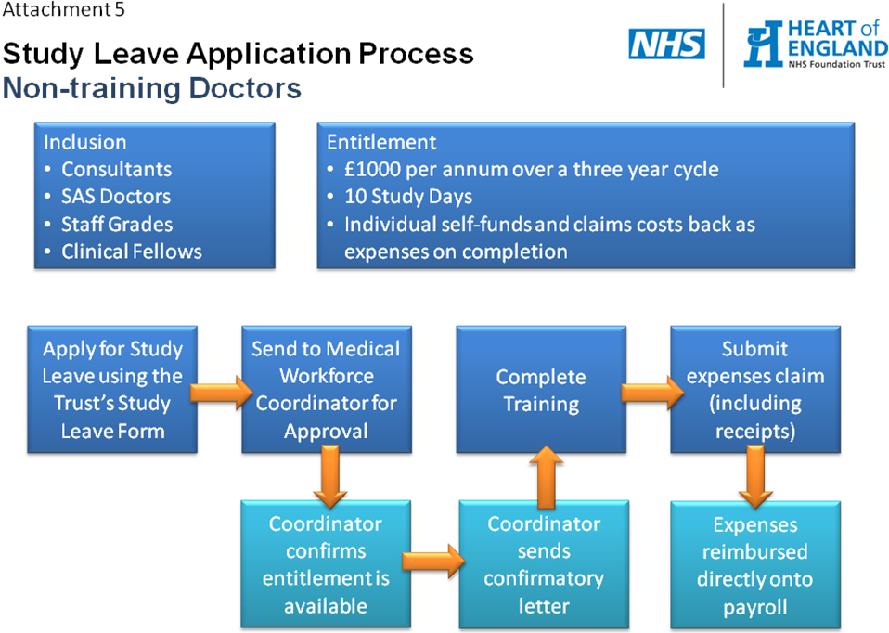

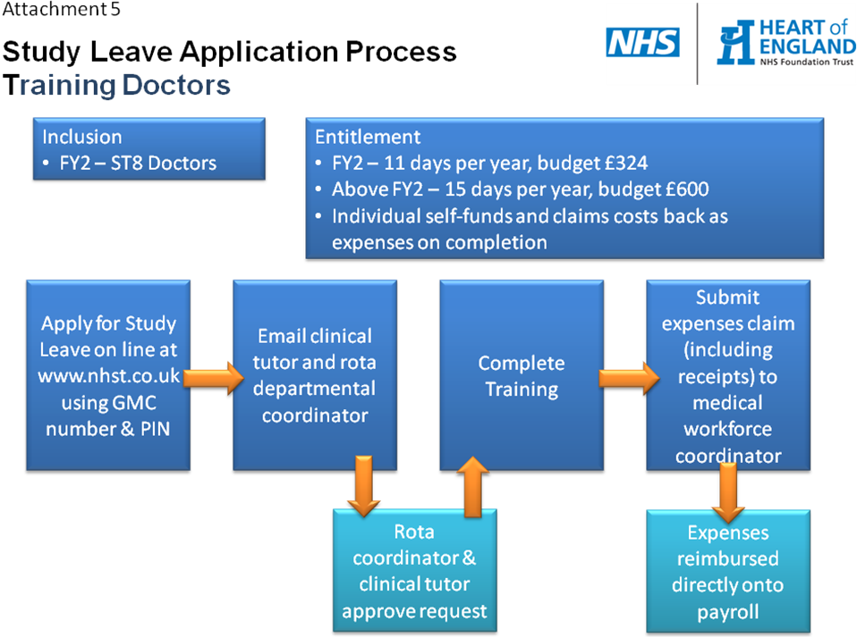

Attachment 6: Example of a Qualifications, Skills and Knowledge Map and Training Needs Analysis
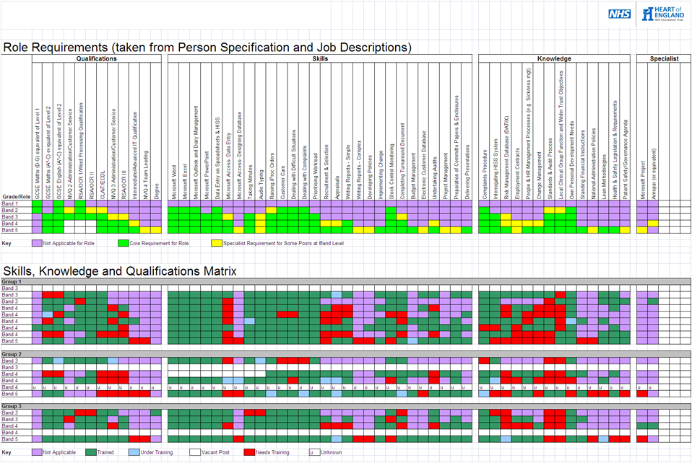
Role requirements from job description and person specification
For each role or grade band in the area, detail the applicability of each requirement
List different roles or grade bands in the area, team or department.
List each member of staff in the area, team or department
Map each member of staff’s training status
Training gaps identified
Qualifications, Skills and Knowledge Map
Training Needs Analysis

Attachment 7: Training Needs Analysis Template



Key used to define training/development status
List each member of staff in the area, team or department
Detail qualifications, skills and knowledge requirements for the team/service

Pre-formatted cells to map each member of staff’s training status

Attachment 8: Example of a Training Plan
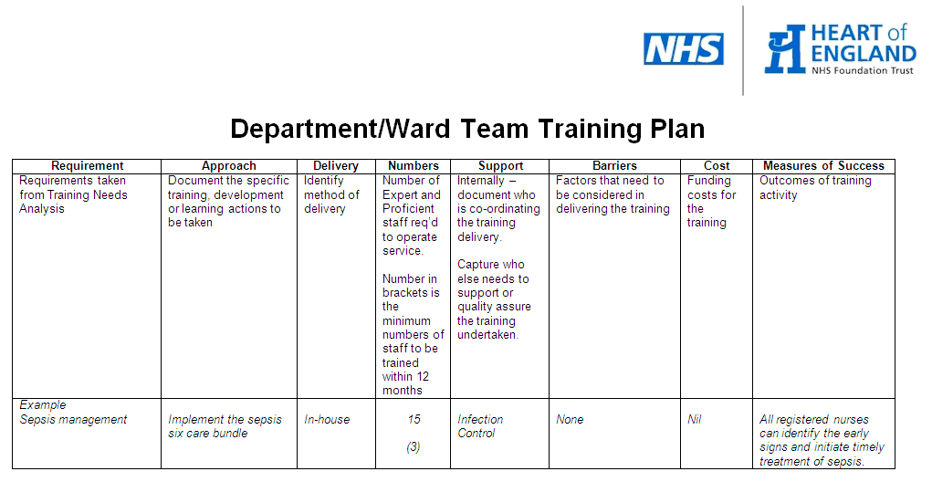

Attachment 9: Quick Reference Guide
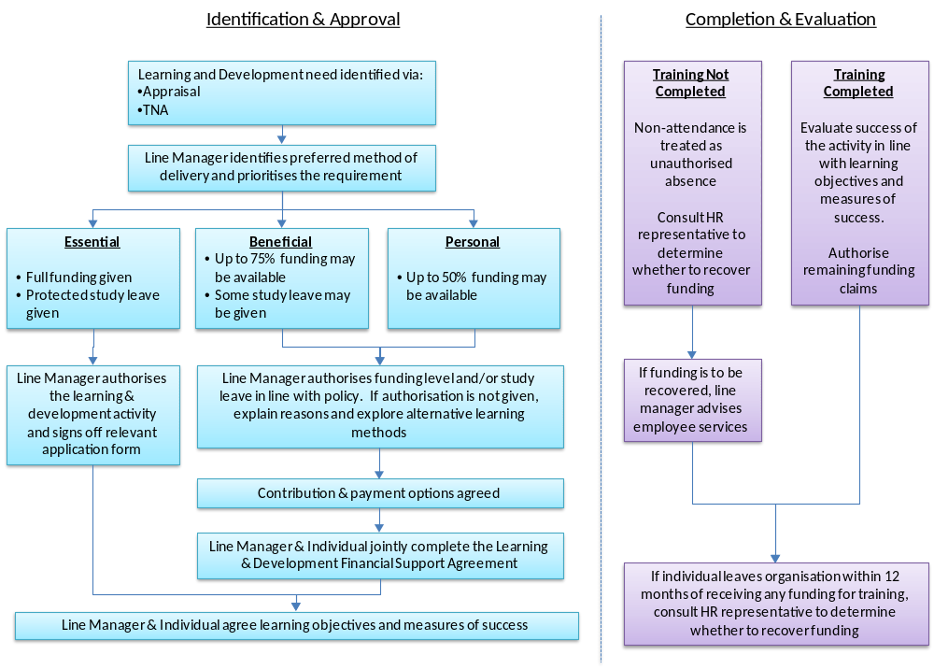

Attachment 10: Learning & Development Financial Support Agreement



Attachment 11: Faculty Evaluation Form




